
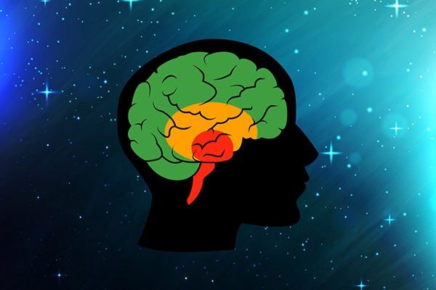



Limbic System – Monkey brain
Responding with emotion -
How you feel and behave are mixed together

Brain Stem – Reptilian Brain
Responding with instinct -
Flight, Fright or Freeze

Cortex – Human Brain
Responding with thinking -
Feel, Stop, Think, Choose, Do
Which brain are you using?

