Train to Teach with Flying High
Why wait for the world to change - we can change it ourselves!
Did you know that Flying High Trust run their own PGCE teacher training course? Do you feel inspired by your child’s school, or know someone that would make a great teacher?
Flying High lead Nottingham’s only Outstanding School Centred Initial Teacher Training Provider (Ofsted 2017).
Based within our trust schools, our unique and bespoke training programme offers you a training year full to the brim with inspiration, opportunities to learn from outstanding leaders in their teaching field and be part of our vision for training the BEST teachers for our children.
The PGCE/QTS course runs for 1 year and offers a school led route where you will learn from outstanding specialist leaders of education and excellent placements in our trust and partnership schools.
If you are interested in training to teach call Jo on 07432 016112 for more information or email jvenables@iltt.org.uk.

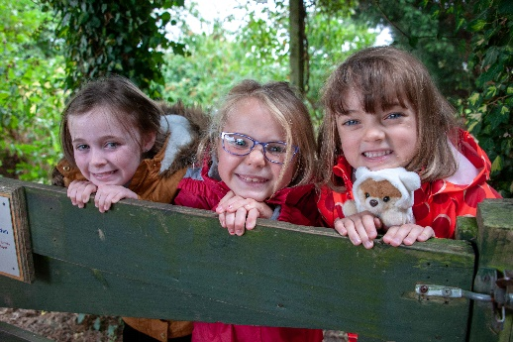
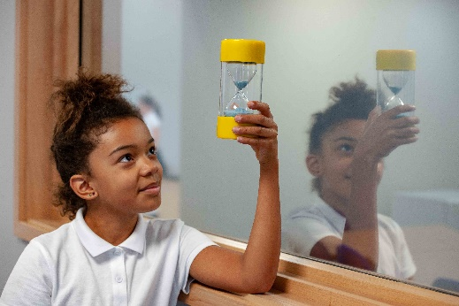
www.inspiringleadersscitt.com

